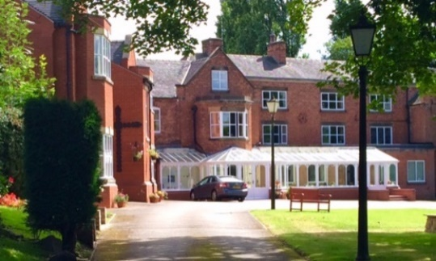
OBLATE RETREAT AND SPIRITUALITY CENTRE

Group booking form

Name of Group………………………………………………………………………………………………………
Number of people…………………………………………………………………………………………………...
Dates:..………………………………………………………………………………………………………………
Nature of Event (eg, workshop, retreat, meeting etc)……………………………………………………………….

Contact Person……………………………………………………………………………………………………..
Address……………………………………………………………………………………………………………
………………………………………………………………………………………………………………………
………………………………………………………………………………………………………………………
Telephone……………………………………………………………………………………………………………
Email………………………………………………………………………………………………………………...

Dietary requirements:
Our catering team will do their best to meet specific dietary needs, for example, vegetarian and gluten free, however, given our resources we cannot accommodate individual preferences. Please contact the Centre if you have any specific concerns or needs.
Please be aware that in our kitchen we use nuts, dairy, wheat, gluten, soya, eggs and other allergens. Please provide details of dietary needs two weeks before you are due to arrive at the Centre.
Celebration Meals:
Our catering team are available to provide a Celebration Meal during your stay. Please let us know if you wish for the details of the menu and associated costs.

Room Allocation:
A rooming list will be provided to you, three weeks prior to your arrival. Please complete and return to us two weeks before your group is due to arrive. Alternatively, please let us know if you would like us to allocate rooms to your group.
Delete as appropriate: We will allocate ourselves / Please allocate our rooms

Other facilities required:…………………………………………………………………………………………….
………………………………………………………………………………………………………………………

Chaplaincy services:
Please indicate whether your group will require chaplaincy services, such as the celebration of Mass during your stay with us.
……………………………………………………………………………………………………………………………………

Payment:
A £200.00 non-refundable deposit is required to secure your group booking. Deposits can be paid by cheque or by credit card. Please make cheques payable to: Oblate Retreat Centre.
Deposit receipts are sent only on request. Do you require one? Y / N
Where possible the balance of payment should be made 7 days in advance. Alternatively, it can be made upon arrival by contacting the Centre in advance.
Cancellation Policy:
It is our intention to ensure the financial sustainability of the retreats and programs we provide at the Wistaston Hall. Cancellations & refunds are managed on an individual basis. Cancellations represent an expense to the Centre and a lost opportunity for others to participate in the retreats and programs. If an individual booking is cancelled more than 14 days before the event, then there will be a refund of the total paid less the standard deposit. If the centre must cancel an event, then there will be a full refund.

Numbers Policy:

Please confirm your final group numbers no later than two weeks before your event. After this date, except in exceptional circumstances, the group will be charged for the confirmed number of participants as the centre will have ordered food and made other preparations for your group’s arrival.

Use of your information:

Information provided on this form will be held by the Oblate Retreat and Spirituality Centre. Information provided may be used to contact you, for example by email, text or phone call to update you with details of events. As per European GDPR regulation, by signing this form you are providing Oblate Retreat and Spirituality Centre consent to process your personal information. A full copy of our Privacy Policy is available on our website. By signing this form, you are confirming that you are consenting to the Oblate Retreat and Spirituality Centre holding and processing your personal data and keeping you informed of our events.

Signed:………………………………………………………………………….. Date:…………………………….

We look forward to welcoming you. If you have any queries, please do not hesitate to contact us.
Please retain a copy of this form for your own records.

Please return completed forms to:

Oblate Retreat Centre
Wistaston Hall
89 Broughton Lane
Crewe
CW2 8JS

e-mail: director@oblateretreatcentre.org.uk

Telephone: 01270 568 653
Website: www.oblateretreatcentre.org.uk

