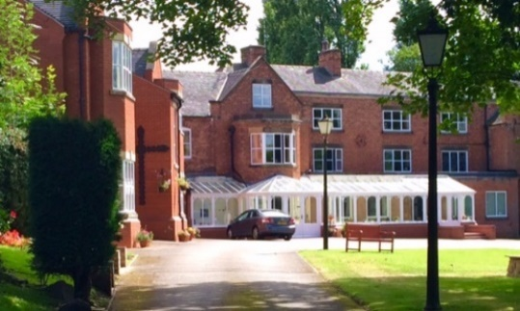
OBLATE RETREAT AND SPIRITUALITY CENTRE

Individual booking form.

Name ……………………………………………………………………………………………
Address………………………………………………………………………………………….
…………………………………………………………………………………………………..
…………………………………………………………………………………………………..
Telephone/Mobile………………………………………………………………………………..
Email……………………………………………………………………………………………

Event……………………………………………………………………………………………
Event Dates……………………………………………………………………………………...

Accommodation:
Residential / Non-residential…………………………………………………………………….
Room (single/twin/double)………………………………………………………………………
Ground floor room requested. YES / NO
A small number of ground floor rooms are available for people with limited mobility.
Would you be willing to share a room and who with?..................................................................
…………………………………………………………………………………………………..

Dietary requirements:
Vegetarian…… Gluten free…… Other (please specify)……
…………………………………………………………………………………………………..
…………………………………………………………………………………………………..
(Please be aware that in our kitchen we use nuts, dairy, wheat, gluten, soya, eggs and other allergens. Our catering team will do their best to meet specific dietary needs, however, given our resources we cannot accommodate individual preferences. Please contact the Centre if you have any specific concerns or needs.)

Payment:
A £50.00 non-refundable deposit per person is required to secure your place. Deposits can be paid by cheque, online or by credit card.
Please make cheques payable to: Oblate Retreat Centre.
Deposit receipts are sent only on request. Do you require one? Y / N
Where possible the balance of payment should be made 7 days in advance. Alternatively, it can be made upon arrival by contacting the Centre in advance.
Cancellation Policy:
It is our intention to ensure the financial sustainability of the retreats and programs we provide at the Wistaston Hall. Cancellations & refunds are managed on an individual basis. Cancellations represent an expense to the Centre and a lost opportunity for others to participate in the retreats and programs. If an individual booking is cancelled more than 14 days before the event, then there will be a refund of the total paid less the standard deposit. If the centre must cancel an event, then there will be a full refund.

Use of your information:

Information provided on this form will be held by the Oblate Retreat and Spirituality Centre. Information provided may be used to contact you, for example by email, text, or phone call to update you with details of events. As per European GDPR regulation, by signing this form you are providing Oblate Retreat and Spirituality Centre consent to process your personal information. A full copy of our Privacy Policy is available on our website. By signing this form, you are confirming that you are consenting to the Oblate Retreat and Spirituality Centre holding and processing your personal data and keeping you informed of our events.

Signed:…………………………………………………………………………………………..

Date:……………………………………………………………………………………………..

We look forward to welcoming you. If you have any queries, please do not hesitate to contact us.
Please retain a copy of this form for your own records.

Please return completed forms to:

Oblate Retreat Centre
Wistaston Hall
89 Broughton Lane
Crewe
CW2 8JS

e-mail: director@oblateretreatcentre.org.uk

Telephone: 01270 568 653
Website: www.oblateretreatcentre.org.uk

